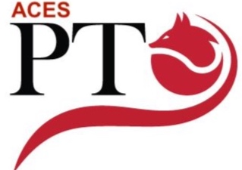
ACES PTO MEETING Agenda 4/19/2022

- Call to Order
- Approval of Minutes
- Budget Approval- Jason Terman
- Old Business

- New Business
- Teacher Appreciation week
- PTO Board Nominations
- 6th Grade Gift
- Committee Reports
- PTOC
- Restaurant Night- Jenna Shaw/Christina Majka

- Principal’s Report
- Open Forum

